IST 707 – Homework 4

Federalist Papers

1 Introduction 2

2 Analysis & Models 3

2.1 About the Data 3

2.2 Exploratory Data Analysis 4

2.3 Models 6

2.3.1 Text Vectorization 6

2.3.2 K-Means Clustering 7

2.3.3 Hierarchical Clustering 8

2.3.4 Expectation Maximization 9

3 Results 10

3.1.1 K-Means Clustering 10

3.1.2 Hierarchical Clustering 13

3.1.3 Expectation Maximization 16

4 Conclusions 17

# Introduction

The initially written Constitution of the United States of America, the articles of confederation, granted Congress the power to conduct foreign policy, maintain armed forces, and print money. But in practice, this centralized government body had little authority over the individual states, including no power to levy taxes or regulate commerce, which hampered the new nation's ability to pay its outstanding debts from the Revolutionary War.

In May 1787, 55 delegates gathered in Philadelphia to address the Articles of Confederation deficiencies and the problems that had arisen from this weakened central government. The document that emerged from the Constitutional Convention went far beyond amending the Articles, however. Instead, it established an entirely new system, including a robust central government divided into legislative, executive, and judicial branches.

As soon as 39 delegates signed the proposed Constitution in September 1787, the document went to the states for ratification, igniting a furious debate between "Federalists," who favored ratification of the Constitution as written, and "Antifederalists," who opposed the Constitution and resisted giving strong and more robust control to the national government.

In support for ratification of the proposed U.S. Constitution, a series of 85 essays appeared in the Independent Journal, under the pseudonym "Publius." Addressed to "the People of the State of New York," the articles now known as the Federalist Papers were written by the statesmen Alexander Hamilton, James Madison, and John Jay, leading supporters of the Constitution and the vital national government it created. They would be published serially from 1787-88 in several New York newspapers. They used the pseudo name to avoid being charged for betraying the constitutional convention, which they are part of. (Federalist Papers, n.d.)

Since the original authors used pseudo names for publication, and as the writers themselves released no complete list, no one will ever know for sure. In this analysis, we will explore some 12 articles disputed on the origin of the author.

# Analysis & Models

## About the Data

|  |  |
| --- | --- |
| We will have a full text of the authors' articles in a directory named "FedPapersCorpus," and each article is stored as a text file. The files are named after the author and also have the sequence number in which they are published. And the disputed are designated as "dispt." Figure 1 shows the directory and filename structure.  Figure 2 shows the sample content of the article stored in the text file. We can see it has a lot of control characters and other symbols present. | Figure |

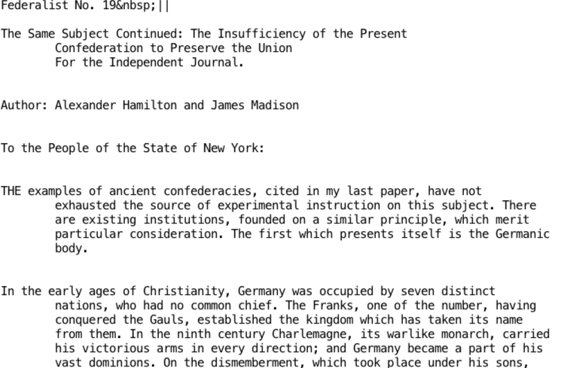

Figure

## Exploratory Data Analysis

|  |  |
| --- | --- |
|  |  |
|  |  |
|  | |

Figure

We will start with separating the articles by their author and try to look at the top 30 words; we will then plot the word cloud to see similarities. Figure 3 shows the word clouds for each author and the disputed ones. From the top stories, we can see the disputed ones have prominent words "will", "state", "govern", "people". These disputed top words were used by all three authors; some are often by others. But we can't for sure attribute the article to anyone.



Figure

|  |  |
| --- | --- |
| We will look at the sequence the authors wrote articles. Figure 4 shows Hamilton started the series, which jay followed, and then Jay only wrote article 64. But the streak of writing tells us something, especially around the disputed papers, Madison is writing that streak, and the last two might be either Hamilton or Jay. |  |

## Models

### Text Vectorization

We will convert the text data to the numeric form; we will read the data using the Corpus directory source, which will read each text file as an individual document and have the file name as the document id. We will also fix the document id just to have the author and the sequence information alone.

We will then use the Document Term Matrix to convert the document corpus to a document matrix. We will also remove the stop words, punctuations, and numbers from the corpus. And we will remove the least and most used words from the document.

To reduce the overall bag of words, we can convert the words to their root form, which we can achieve through stemming or lemmatization

Lemmatization is the process of grouping together the inflected forms of a word so they can be analyzed as a single item. It is implemented with the use of a vocabulary and morphological analysis of words, aiming to remove inflectional endings only and to return the base or dictionary form of a word, which is known as the lemma

Stemming is a more straightforward form of lemmatization, which doesn't understand the context and cannot discriminate between words with different meanings depending on the part of speech. However, stemmers are typically easier to implement and run faster, and the reduced accuracy may not matter for some applications**.**

Figure 5 shows the document conversion process.

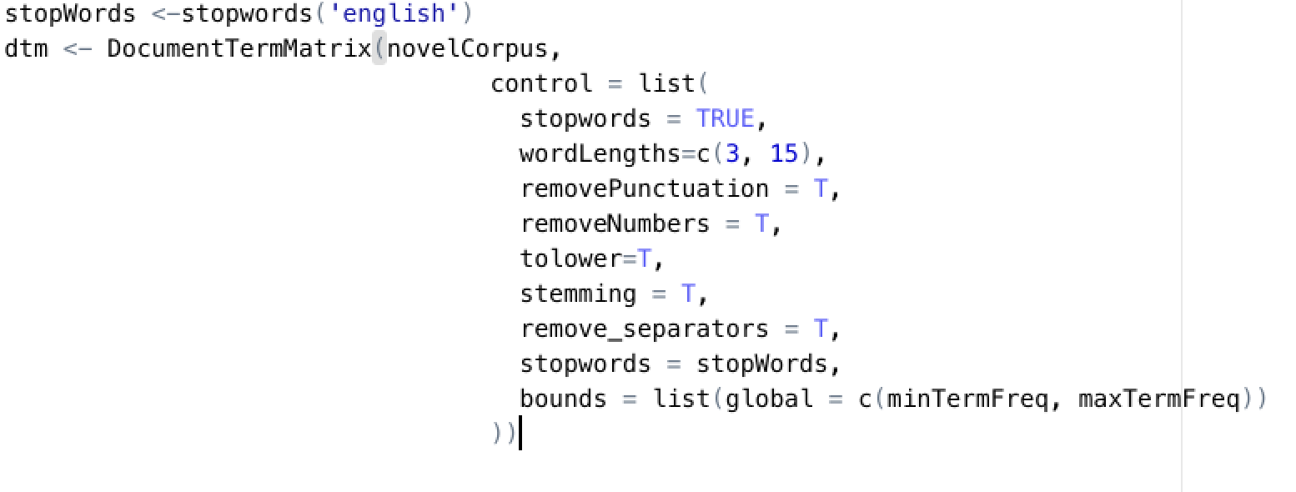

Figure

Once we convert the document to the document matrix, we will also create a normalized version of the matrix to use with our distance methods. Remember, we are trying to compare how similar the documents are to group them, so it's essential to bring all of the documents to a standard scale. For our use, we will assign values of each term concerning the overall words present in the document.

### K-Means Clustering

We will find out how many clusters to be divided from the data by using an unsupervised algorithm by their silhouette distance. We get around seven distinct clusters, and we run the K-means clustering with seven centers, and we look at how each article is grouped.

The first fit we started with all the words, and that resulted in a very noisy network. We were not able to find any distinctive features. So we went back and removed the stemming and stop word removal, which increased the noisy stop word like "the".

|  |  |
| --- | --- |
| We started by looking at the words' frequency and realized the top words are the most common, and started removing them by frequency. The words with more than 1000 counts are expected so that we will remove them. Figure 7 shows the most common phrases we pulled.  Then we were trying to test whether the authors use any unique words that will distinguish them. So we will remove the low-frequency words and some of the high-frequency words from the feature list. Figure 6 shows the final frequency list we arrived at.    Figure | Figure |

### Hierarchical Clustering

Then we will be using hierarchical clustering to group our data set; we will be using only the selected features we arrived at k-means. To compute the hierarchical cluster, we will first calculate three distance measures Euclidean, Cosine, and Manhattan matric. We will use hcluster to group them; we will do it over both normalized and regular term matrix.

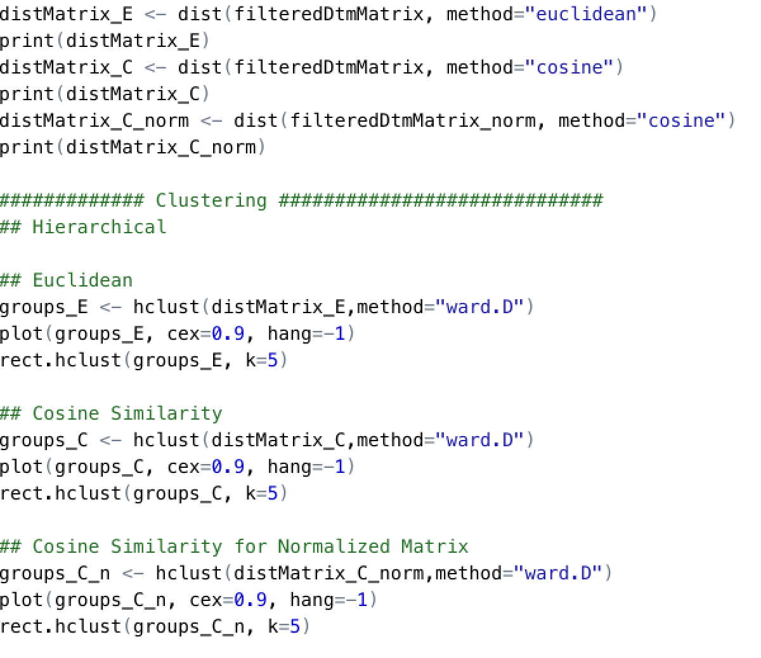

Figure

### Expectation Maximization

Finally, we ran another grouping method called expectation maximization to verify our results.

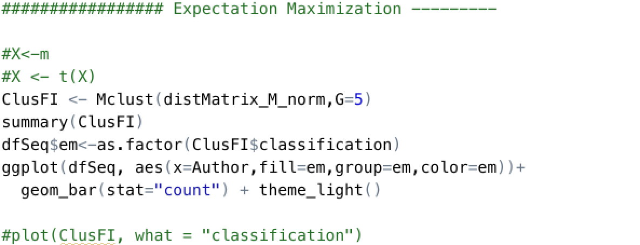

Figure

# Results

### K-Means Clustering

The first iteration of cluster estimation recommended 7 clusters with all the features, but the result of the first iteration was too noisy. We cannot see how the cluster is formed visually. We simply had too many features to plot. Figures 10 and 11 shows the initial cluster estimation and the final cluster allocation for all the authors.

|  |  |
| --- | --- |
| Chart, line chart  Description automatically generated  Figure | Chart, bar chart  Description automatically generated  Figure |

After iterating through the features set, we were able to arrive at an optimal feature, which has 400-500 frequency in the whole corpus. The estimated clusters showed two, but we could not decide which author wrote the disputed articles since the sets contained both the authors. After server rounds of iteration, we were able to finally arrive at a cluster size of 5, where we could see the clear segregation of authors.

Figure 12 shows the recommended cluster size for selected features. Figure 13 shows the cluster distribution and the disputed article location. The upper part is where Madison's articles were, along with the disputed ones. Here we can see most of the disputed articles are located near author Madison's article. This gave a clear indication that Madison wrote the disputed articles in question.

Figure 14 shows the cluster grouping by Authors.

Figure

Figure

Figure

### Hierarchical Clustering

In our hierarchical clustering with Euclidian distance, we could see; all the disputed articles were grouped in Madison. Figure 15 shows the dendrogram of the five split hierarchical clusterings.

Figure 16 and 17 shows the dendrogram of cosine distance without normalization and with normalization respectively. Figure 18 shows the Manhattan distance cluster. The remaining two distances didn't classify the disputed articles well.

It's interesting the simple Euclidian distance is giving us the desired result.

Figure

Figure

Figure

Figure

### Expectation Maximization

The expectation-maximization gave us too many details; the final plot is too dense, we might have to reduce the number of features to see what it is giving us. The authors' cluster group chart shows a similar result as k-means, which might be even better since most of the disputed articles are grouped in one. Figure 14 shows the EM cluster grouped by Authors.

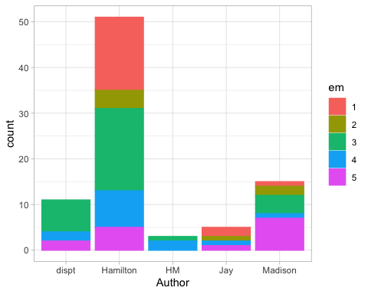

Figure

# Conclusions

When we looked at all of the words, the authors looked similar, but when we drilled down to specific words that are used more by individual authors, we were able to classify the disputed articles to its author.

|  |  |
| --- | --- |
| The words listed on the right indicate who wrote the articles concerning the disputed ones.  From our analysis, we can see James Madison wrote the disputed articles. And his most used words are most, upon and new.  And for the co-authored articles, they sit more with Alexander Hamilton. |  |